INS3121
SOIL MECHANICS
MIDTERM II
December 14th, 2016

Name and Surname:
Q.1/22p | Q.2/28p | Q.3/25p | Q.4/25p | TOTAL
Number:
Group:

- a. What is consolidation coefficient? Explain briefly how it can be determined (5p).
- What is preconsolidation pressure? Explain how it is used in settlement calculation (5p).
- What are the parameters that affect shear strength of clayey soils? (5p)
d. Which laboratory tests are used to determine the shear strength parameters of soils? Briefly describe the shear box test (7p).

- An oil storage tank will be constructed on a soil profile shown in the below figure. If the preconsolidation pressure (σʹ_{p}) of the clay layer is 200 kPa,
  - Determine whether the soil is normally consolidated or overconsolidated (12p).
  - Compute the settlement that will take place underneath the center of the tank due to primary consolidation of the clay layer. (Effective vertical stress increment due to oil storage tank is (Δσʹ) 75 kPa.) (16p)
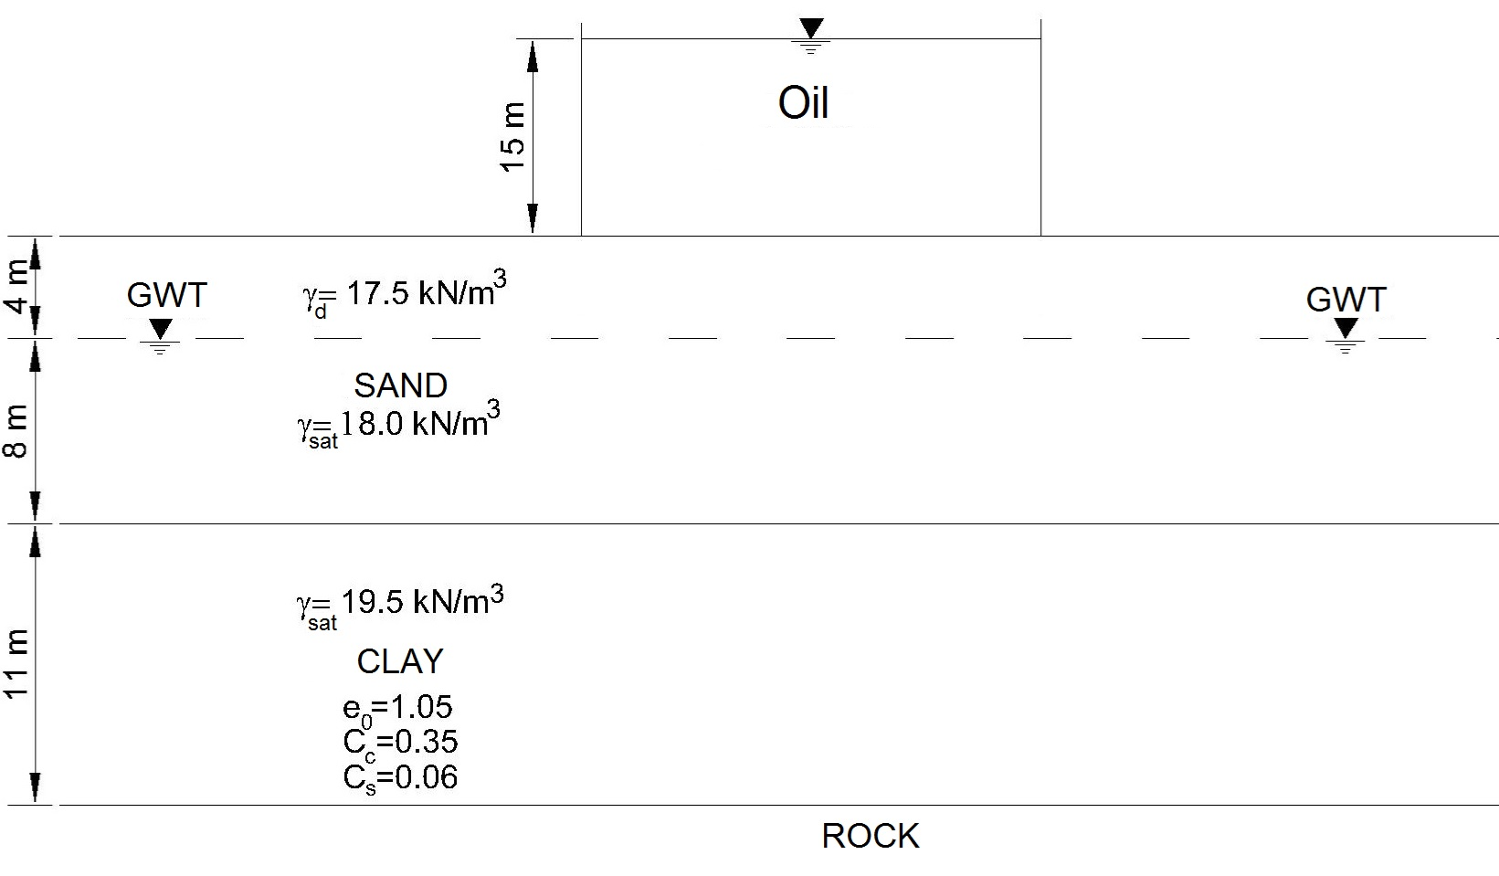

- A raft foundation in 10 m x 10 m dimensions will be constructed as shown in the below figure. The odeometer tests performed on a sample recovered from the clay layer showed that the clay layer is normally consolidated.
- Compute the settlement of the clay layer caused by the primary consolidation of the clay layer (Determine stress increase at the middle of the clay layer by using 2:1 Method) (15p).
- Compute the settlement that will take place after 5 years (10p).

U (%) | 10 | 20 | 30 | 40 | 50 | 60 | 70 | 80 | 90
T_{v} | 0.008 | 0.031 | 0.071 | 0.126 | 0.197 | 0.287 | 0.408 | 0.567 | 0.848
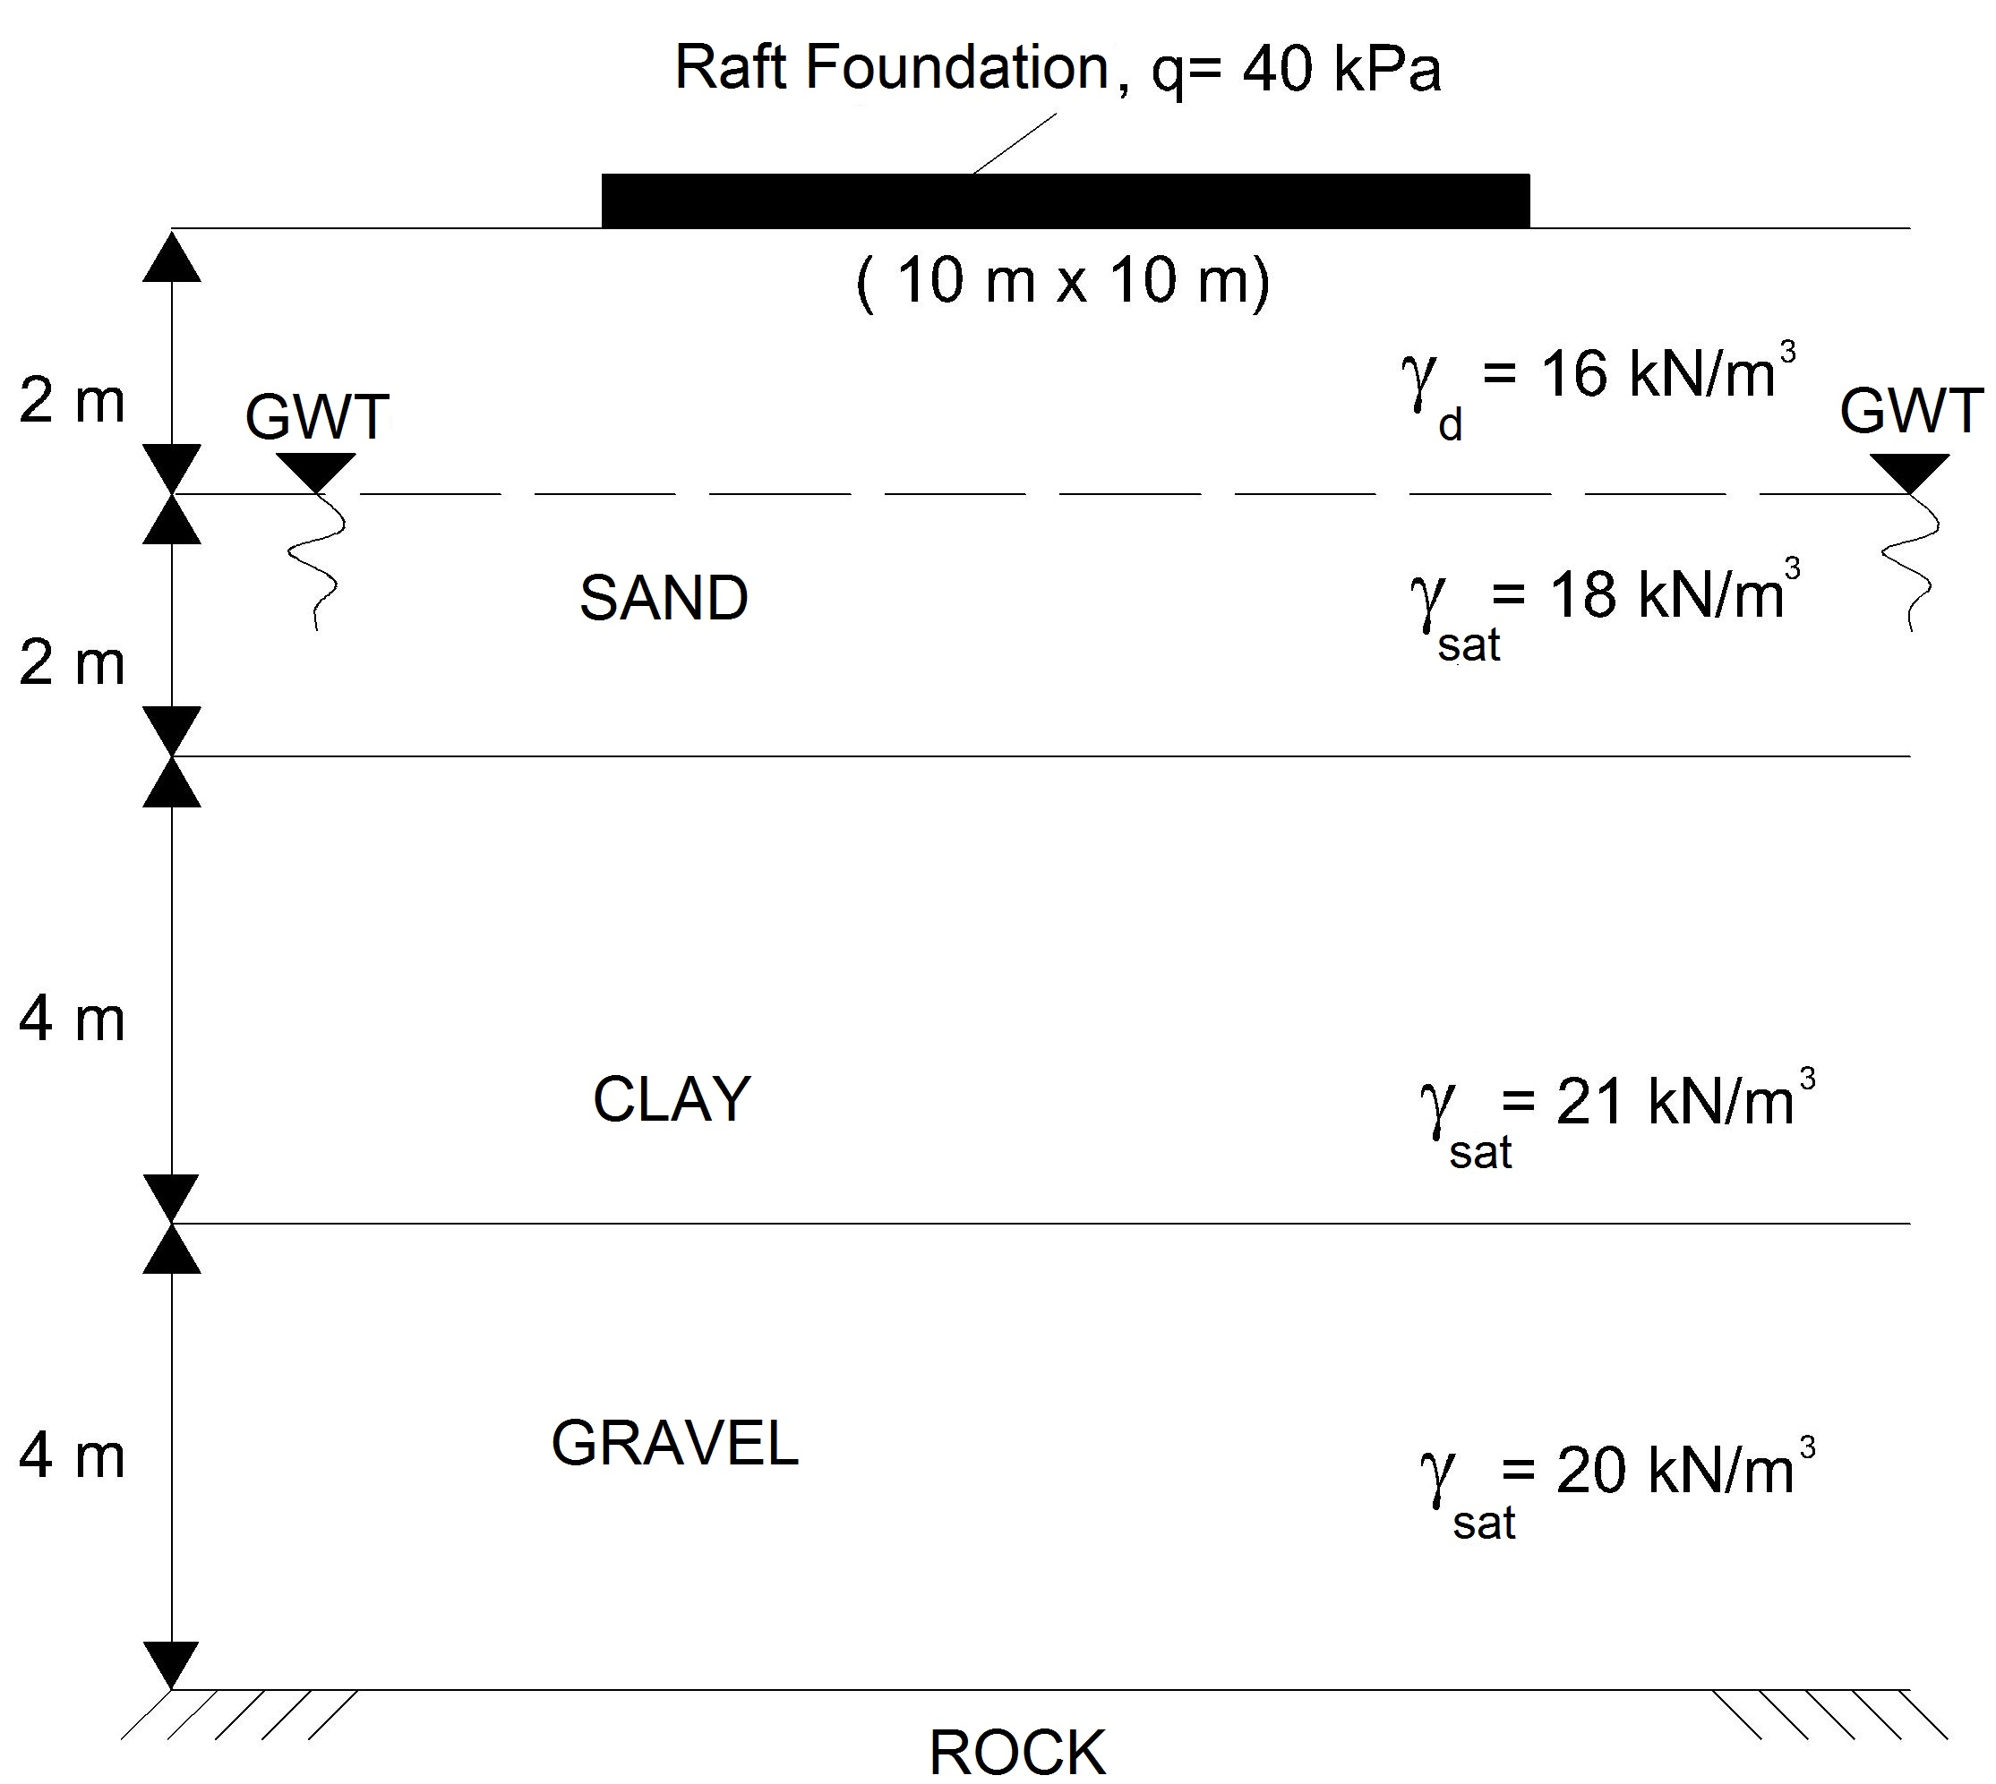

c_{v}=7.28 x 10⁻⁵ cm²/sec e= 1.1
Cc=0.34 Cs=0.05

- An unconfined compression test was carried out on a saturated clay sample that has a diameter of 38 mm and a height of 76 mm. The test result obtained from the experiment is given in the below figure. Based on this result,
  - Determine the undrained shear strength (c_{u}) of the clay soil (Calculate the area correction with A_{f} =A₀/1-ε_{f}) (12p).
  - Plot the Mohr Circle for the unconfined compression test and show undrained shear strength value on the Mohr Circle (8p).
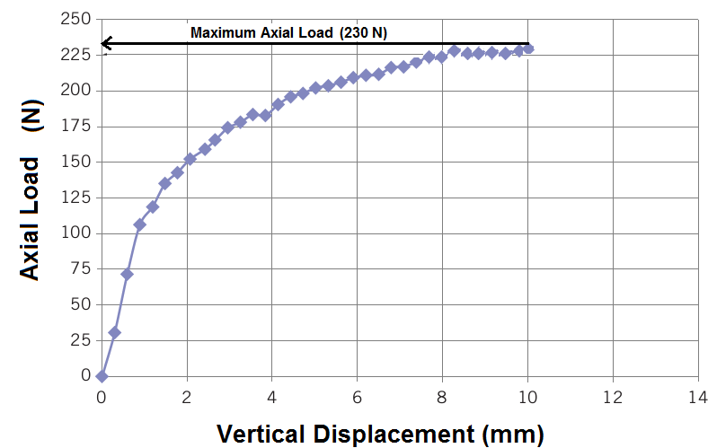
  - Describe the consistency of the clay soil according to the description given in the below table (5p).

Discription | c_{u} (kPa or kN/m²)
Very Soft | <10
Soft | 10-25
Medium Stiff | 25-50
Stiff | 50-100
Very Stiff | 100-200
Extremely stiff | >200

Time is 80 minutes. Good Luck…

